**Amrita Vishwa Vidyapeetham**

**Amrita School of Engineering, Coimbatore**

**Department of Computer Science and Engineering**

**Topic: Linux Commands(Lab-2)**

------------------------------------------------------------------------------------------------**19CSE213 Operating Systems Laboratory – Linux Commands**

**Name :** R.Abhinav

**Roll. No:** CB.EN.U4CSE19453

**PART A**

1. List all the directories only using echo command **:**

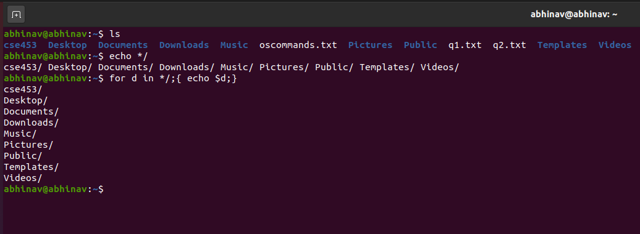

1. List the calendar of September 1752 and explore :

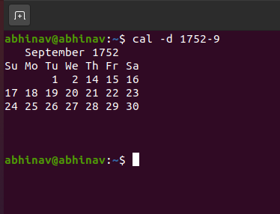

1. Display the time of the day :

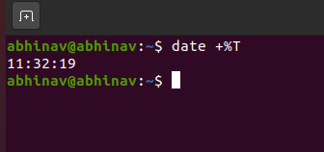

1. **Create a directory by your rollno i.e., cse453:**

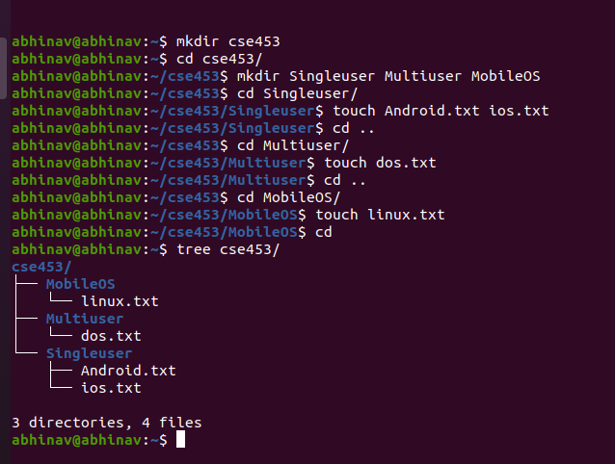

1. **Move the files to appropriate directory :**

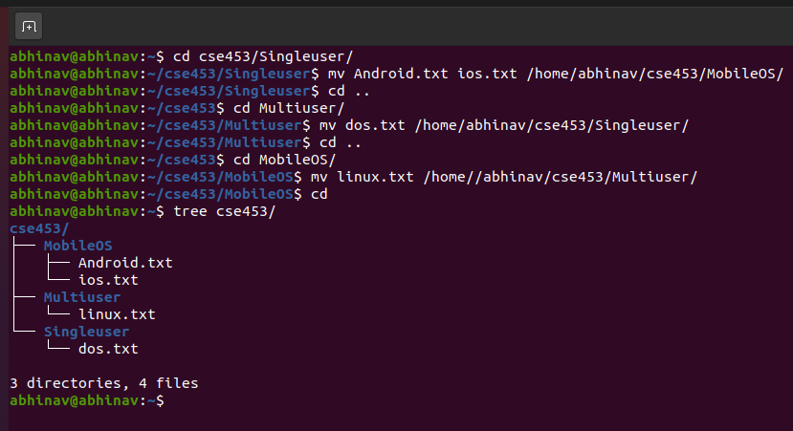

1. **List all the directories and files in directory with name as your rollno :**

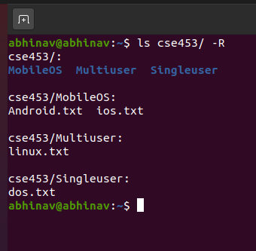

1. **List the size of all files (hiddenfiles also) and folders in desired scale format, directories should not be displayed.**

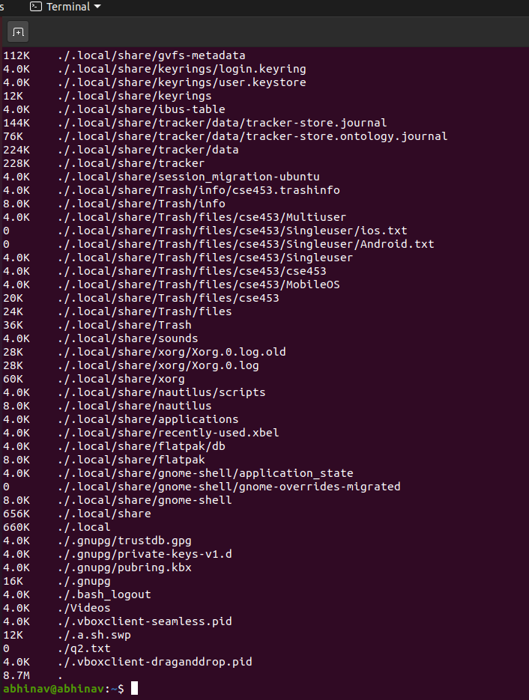

1. **Change the permissions of the file DOS.txt give read and write permissions to user and group**

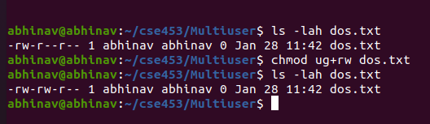

1. **List all the environment variables and display PATH :**

**Command :** printenv

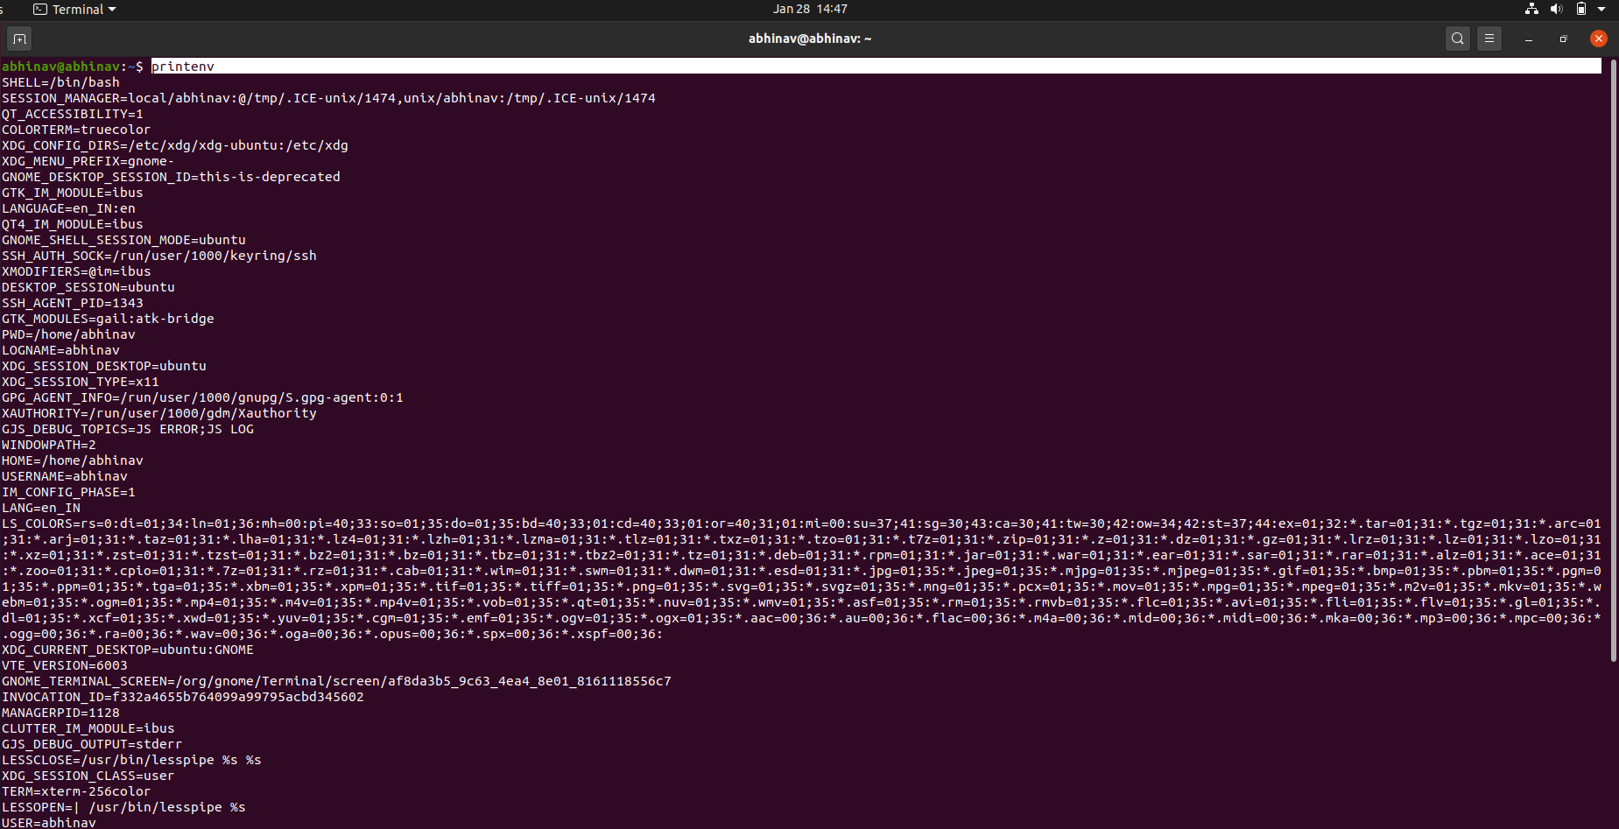

1. **Change the prompt. And change it back to original prompt.**

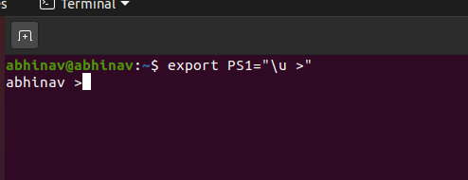

1. **Copy the file /etc/passwd into your home directory.**

**Command :** sudo cp /etc/passwd /home/

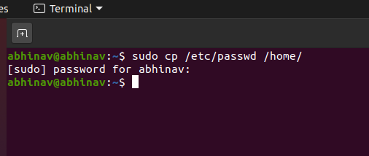

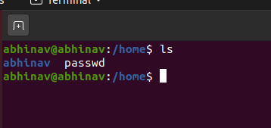

1. **List the usernames and home directory from /etc/passwd in sorted order**

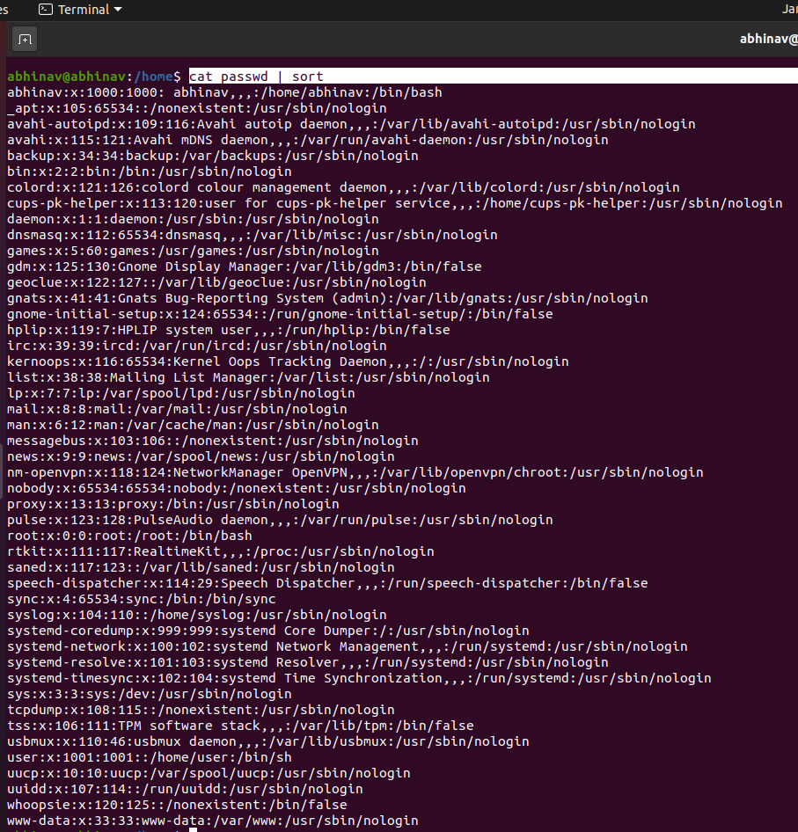

**PART B**

1. **Write a Shell program to check the given number is even or odd.**

**Code:**

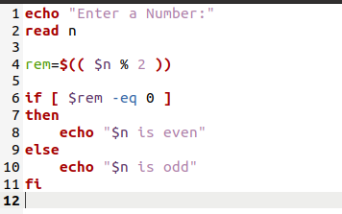

**Output :**

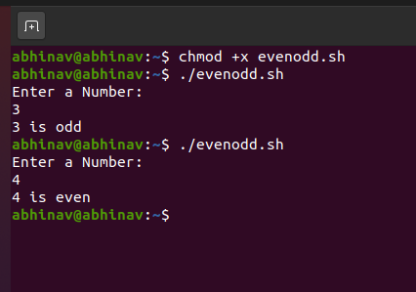

1. **Write a Shell program to find the smallest digit from a number.eg:145 , the smallest digit is 1**

**Script:**

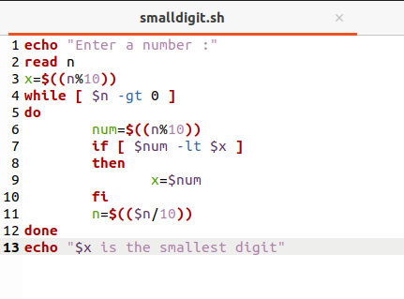

**Output:**

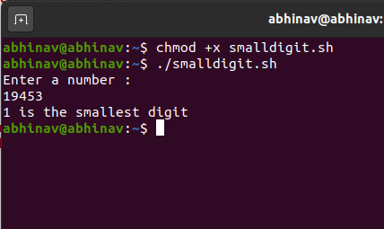

1. **Write a Shell program to find the sum of cube of individual digits of a number.**

**Shell Script :**

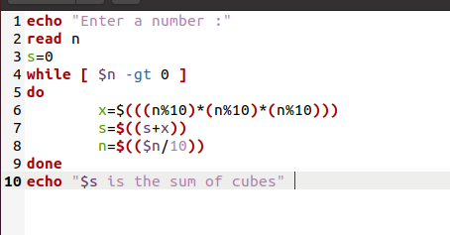

**Output:**

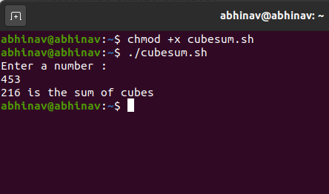

1. **Write a Shell program to generate prime numbers between 1 and 50.**

**Code :**

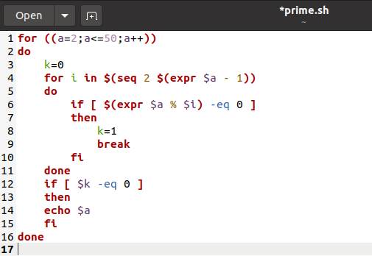

**Output:**

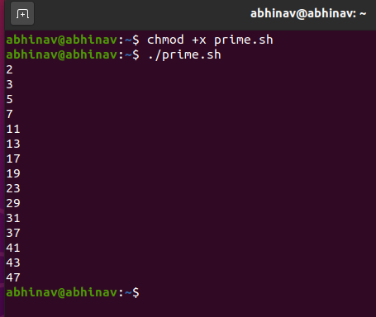

1. **Write a Shell program to generate the directory structure as shown in Part A ,Q.No 4.**

**Code:**

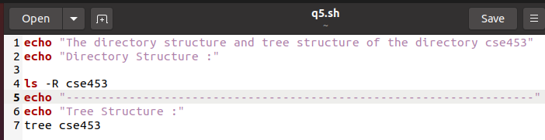

**Output:**

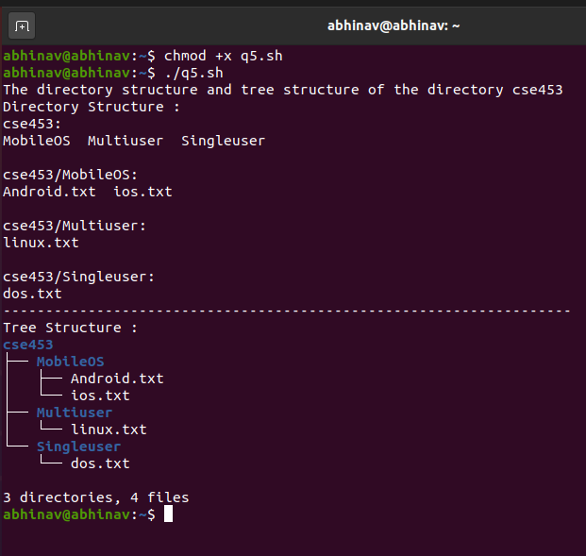

1. **Write a Shell program to check the given number and its reverse are same.**

**Shell Script :**

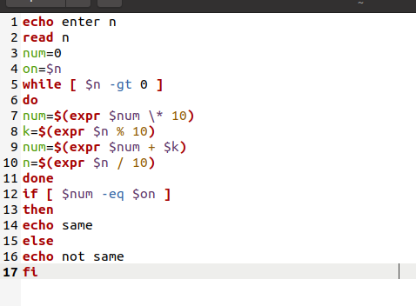

**Output :**

